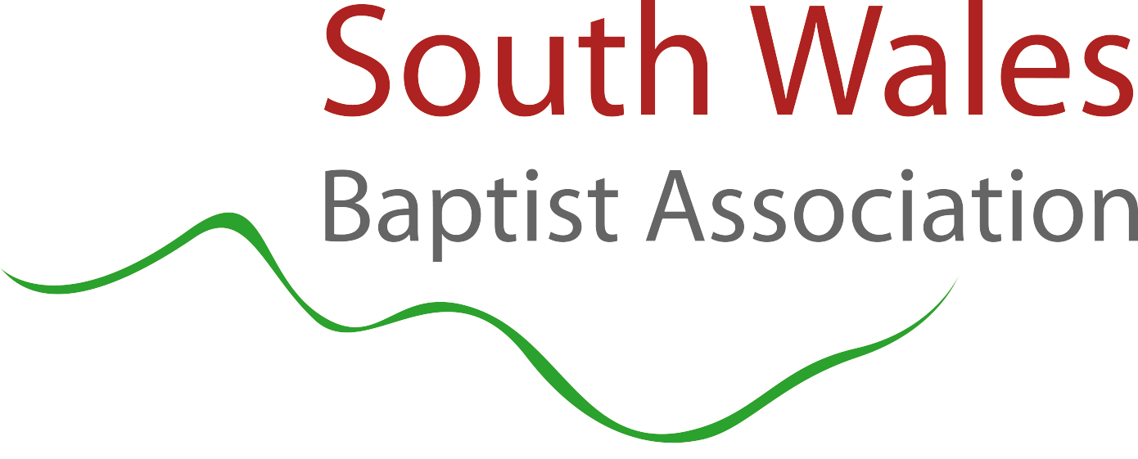
South Wales Baptist Association Moderator Application

Your Full Name:
Address:

Church where you are a member:
Contact Number:
Email:

Signature:

Name of Person You are Nominating? And What Church they are From?

Tell us why you think they would be good at the role of moderator?

Have you spoken to the person about this role and are they happy to be nominated?

