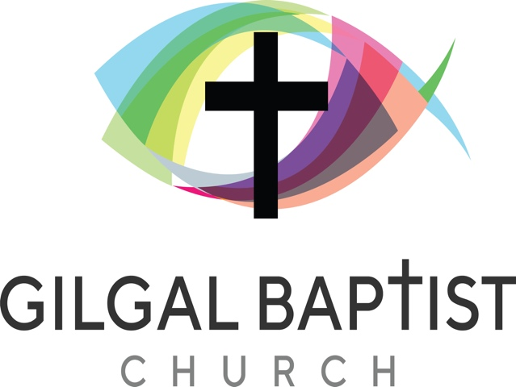
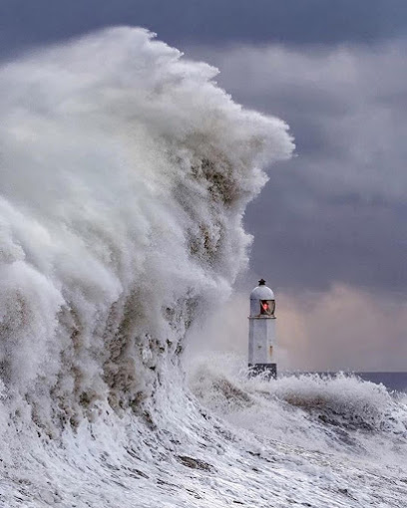

We are a family-friendly, mission-focused church in a seaside resort in South Wales, which will be celebrating its 150th Anniversary in 2022. Our mission statement is “To know Jesus better and to make Him better known”. We have adopted four strategic goals:
- To be a church that families love
- To have a building fit for purpose
- To make disciples that make disciples
- To bring more people to faith in Jesus Christ

Our Associate Pastor, Steve Lock, has overall responsibility for working with Children, Youth and Families, but has been released from youth work in order to fully concentrate on younger children, parents and families. He regularly takes assemblies in the local primary schools, as well as providing lessons, for example at Easter. The new youth worker would seek to build on what has already been achieved and to reinvigorate the work with our 11+ age group, developing youth ministry and, seeking to be involved in the life of Porthcawl Comprehensive School, which happens to be in the same street as the church.

Over the next two to three years there are major changes planned at Gilgal - changes to ensure our buildings are fit for purpose, to keep us abreast with modern worship trends, to serve our community better and to provide the type of flexible facilities that families will enjoy and benefit from. A plan to make our church a place of glory to God.
These will include a new modern entrance to the church itself, an expansion of floor space so as to provide a larger modern reception area with café facilities, better use of space in the sanctuary, with dedicated space for parents with young toddlers and better sound and lighting to brighten up the inside areas.
Longer term plans are to demolish the old church hall and rebuild it as a more 'fit-for-purpose building, so that it can be utilised for both church, youth and community activities, ensuring that we also meet all access requirements for the elderly and mobility challenged persons. We also plan to utilise the church land better so as to create more parking spaces.
For more information see our website: https://gilgal.co.uk, or contact Martin Gillard at gillardmc.com and on 01656 771168.

