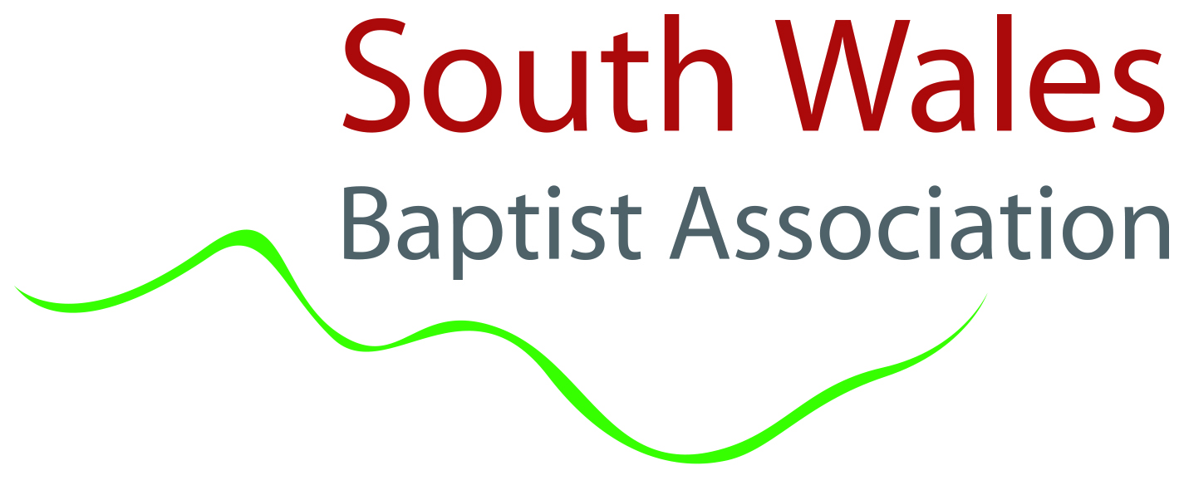
swba.org.uk/internships

Internship Programme
September 2022-June 2023

Overview

The internship is open to those over the age of 18. This includes those just out of education to those in retirement.

Our Internship is an exciting new programme for people who wish to explore a call into leadership in today’s Baptist context. The internship runs over the course of an academic year, from September to June, offering the opportunity for you to explore, experience and better understand leadership within the Baptist movement in South Wales.
​
Leadership and Theological Development
Interns will have the opportunity to develop their leadership skills through interaction with a number of experienced Christian leaders. They will be also able to participate in Pathways, a course run by Cardiff Baptist College, to help equip people for ministry and mission in the local church. This enables theological formation to take place during the internship.

Practical Experience
This is flexible and will depend on the church placement. Examples of areas that might be covered include mission and pioneering (including digital) or children, youth, families, and community.
​
Mentoring
The intern will be provided with their own mentor who will meet with them on a monthly basis and journey with them over the duration of the programme in order to help them reflect critically on their learning experience and aid them in their leadership development.
​
Structure of Programme
We aim to be as flexible as possible, but a typical internship will be structured around a 5 day week (which includes Sundays). This will comprise the equivalent of 1 day for study and mentoring, 3-4 days in a ‘local placement’ and an opportunity to be involved at different points with association life.

Role of the Church

The nature of the internship would be to help develop both church-based ministry and community-based outreach alongside a taste of regional mission and ministry. This would be determined in conversation between the church and the intern, seeking to balance the needs of the church with the gifts and passions of the intern.

Over this 10 month period the intern and church will complete reflections on the process, what God is doing and to help identify opportunities, needs and further areas of development. The SWBA will seek to ensure good communication between association, church and intern.

We see this as a partnership between a Baptist Church and the SWBA. Each party will be responsible for specific areas for the internship jointly and independently, see below:

Church | SWBA
Be involved in the recruitment of intern  Set the programme of activities/church involvement (timetable lead) – in conjunction with intern’s skills/ministry/interests  Direct line management and pastoral care of interns  Ensure the intern has onsite health and safety and fire safety training and follows up to date safeguarding procedures. Ensure the intern meets with the Designated Person for Safeguarding.  Carry out risk assessment of and ensure the right insurance is in place for accommodation  Support the Internship process of theological reflection | Advertise and recruit interns  Take overall responsibility for the internship programme  Aid the organisation of programme of activities/church involvement – in conjunction with interns’ skills/ministry/interests  Facilitate mentoring of the intern  Carry out DBS check for intern and Safeguarding Training  Provide opportunities for Regional and National Experience where possible  Oversee the Internship process and the health and well-being of intern and church  Deal with any disciplinary issues

The timetable for the intern will vary depending on the placement.

Funding – Church & Association
We estimate the internship costs could be:

Housing £650 per month, to include utilities, if no suitable housing is available from the church
Living allowance £300 per month, to include food and general living expenses
Total for 10-month internship with accommodation provided by the church = £3000
Total for 10-month internship with rented accommodation = £9500

SWBA is offering up to 3 internships where the church sorts out housing, and the SWBA provides the living allowance and training.

If these places are filled up internships are still possible but a Church would have to budget for the full cost.

N.B. We recognise that these costs could vary dependent on region, accommodation offered and nature of the internship.

It is important that all people applying for Internships are treated equally and fairly, therefore any housing that is offered will need to be authorised by the SWBA to make sure it is a safe and comfortable environment for the intern.

Selecting the Intern

Internships will be advertised through the Association. We encourage churches to share that information with their congregations.

Information and an application form is available from the Association (office@swba.org.uk) This can be shared with churches to pass on to those they believe might be interested or the individual can contact the association directly.

Those who apply for an internship will be invited for an informal interview to meet with the association and a potential church placement.

The Church and the Association Team will then discuss together the suitability of the individuals who have applied and prayerfully discern the way forward. Outcomes will be communicated to all applicants at the earliest opportunity.

Training

Interns will be expected to attend Pathways which is provided by Cardiff Baptist College. The modules run on a two-year cycle, so we cannot guarantee which will be available during the internship. We estimate an intern over 10 months will be able to complete up to 4 modules.

All the Module facilitators are experienced practitioners in ministry and mission, but Pathways values the interaction of all participants in exploring key issues and fresh perspectives. The modules include:

- Pathways into Christian Belief
Exploring key aspects of Christian Belief and their implications for contemporary life.
- Pathways into Worship
Exploring a holistic approach to worship while developing a number of specific practical skills.
- Pathways into the Bible
Exploring the story and meaning of the Bible and engaging with it today.
- Pathways into Church Leadership
Exploring the practical skills needed for church leadership today, including conflict resolution.
- Pathways into Radical Belief
Exploring a positive Baptist vision for life through our history, principles and contemporary practice.
- Pathways into Preaching
Exploring the art of sermon preparation and effective communication today.
- Pathways into Mission and Evangelism
Exploring the Biblical foundations for sharing in God’s mission and reflection on examples of good practice.
- Pathways into Pastoral Care
Exploring pastoral care today, examining key problem issues, self-awareness and basic counselling skills.
- Pathways into Spirituality and Personal Growth
Exploring what is meant by spirituality and how we develop our relationship with God.
- Pathways into Discipleship and Culture
Understanding the diversity of contemporary culture and exploring how we nurture Christ-like disciples within that world today.
- Pathways into Children’s, Youth and Families work
Equipping both paid and volunteer CYF workers and giving them tools to help in their ministry and mission in the local church.

We are open to exploring other training that may be relevant.

Internship Opportunities
The duration of the programme is 10 months starting from September 2022 (there is some flexibility regarding the start date).

The internship is open to those over the age of 18, including school leavers and those in retirement.

As an intern you will have the opportunity to:

- Discern God’s call on your life for the future;
- Develop your pastoral skills;
- Develop your communication and relational skills;
- Build your confidence;
- Apply your knowledge in a ministerial setting;
- Study a short course at Cardiff Baptist College;
- Discern your gifting and purpose;
- Grow spiritually;
- Develop group leadership skills;
- Develop preaching and discipleship skills;
- Gain practical experience working in mission.

We believe internships are particularly suited to children, youth and families work and community mission.

The internship gives an amazing opportunity for someone wanting to give time and energy to serving God.

Intern Roles & Responsibilities

a. SKILLS/CHARACTER

There is a requirement for this internship position to be filled by a committed and practising Christian.

We are seeking God for interns with the following qualities:
- a passion for God and wanting to grow with Him;
- a desire to reach people with the gospel;
- a love for people;
- a heart to serve others.

Skills we are looking for:

ESSENTIAL
- Be committed to serving God
- Trustworthy and reliable
- Can manage your own time
- Willingness to learn, listen and remain teachable
- Have a ‘can-do’ attitude, getting stuck in and using your initiative
- Able to communicate well on various platforms and willing to grow in this area
- Willingness to build relationships
- Have an openness to views different from your own
- Have a desire to develop the skills the internship is offering

As you may be working with children and/or adults at risk, a DBS check will be required and carried out and you will be required to attend Safeguarding Training provided by the Association.

Application Form

Please complete the form by Wednesday 25th May 2022 and return it to: Association Administrator, South Wales Baptist Association, 54 Richmond Road, Roath, Cardiff CF24 3UR or email to office@swba.org.uk

We aim to confirm placements by mid-July at the latest.

Please ensure all fields (including the name on the top of each page) are filled in correctly with as much information as possible. Any partially completed responses will be omitted and could hinder your application. Should you have any questions regarding the internship please email the office (office@swba.org.uk)

Name:
Address:
Email:
Phone:
D.O.B:

Passions:
What are you passionate about?
What attracts you specifically to an internship with SWBA?
What are the main things that you would like to get from this internship year?

Gifting and Abilities:
In which areas would you be interested in serving in?
What experience or involvement do you have in that/these area?
Please list two referees we can contact (please let them know we will do this) along with a contact email and how you are connected with each referee.
(One of the referees must be in Leadership in your current church)
Please describe any previous experience in Christian or secular work, leadership or initiatives
(e.g. Youth groups, Christian Union, summer camp, paid employment, church service - include anything that has been significant to you)
How would those who know you best describe your character or temperament?
\
Church Life:
Briefly describe how and when you became a Christian
How long have you been involved in church life?
Which church do you belong to and how long have you been there?

Work and education:
Which schools/colleges/universities did you attend?
(Please list all applicable in chronological order)
If applicable, what were your GCSEs or International equivalent?
(Please include your grades)
If applicable, what Post-16 education qualifications do you have?
(Please include your grades)
Do you have any other qualifications?
Please list any employment and your current occupation where applicable.
Are you comfortable with the financial and time commitment? Is there anything else we should know?

The boring but important stuff!

- The 2022/23 Intern programme will run for about ten months from September 2022.
- Interns come to SWBA as volunteers rather than employees and the relationship between the church, association and the Intern is one of mutual trust rather than contract.
- Interns will not be charged for the Internship, but they will receive a small financial support from SWBA. Housing provision is to be discussed with the church.
- Interns will normally be expected to support themselves above the financial provision given.
- If not a UK resident the applicant will need to be in possession of any necessary work permits before submitting an application. International applicants will not be considered if relying on a student visa to remain in the UK and will need to arrange all visa permissions by themselves.
- The Intern will need to agree to the time commitment with the church which will include Sundays.
- Interns will be expected to live within easy travelling distance of the church.
- Interns will be expected to be fully committed to the Church and the Leadership team for the duration of the Internship which will include regular attendance at Sunday gatherings.
- The church/ association work will involve varied daytime, evening and weekend hours.
- Interns will be encouraged to take 20 days holiday (or equivalent hours) during their Internship, plus Public Holidays.

I have prayerfully considered all the information and insight I have gained about the South Wales Baptist Association Internship Programme so far and have fully and frankly completed this form to the best of my ability.

I hereby authorise The South Wales Baptist Association to obtain references to support this application and accept and release The South Wales Baptist Association and my placement church and referees from liability caused by giving and receiving information. I confirm that the information given on this form is correct and any misleading or falsification of information may be proper cause for rejection, or if chosen, cause for dismissal.

I understand that the information given on this form will be held by The South Wales Baptist Association for the purpose of processing my application in conjunction with the Association’s privacy statement and Data Protection Policy.

Signed: ___________________________________ Date:__________________

