South Wales Baptist Association 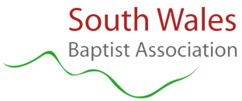

Association Safeguarding Lead - Role Description
The person appointed to be the Lead on Safeguarding in the South Wales Baptist Association (SWBA), will be a suitably qualified and experienced team member, who will:
- Provide a first point of contact for advice when a safeguarding issue arises in a member church, whether child protection or adult at risk;

- Offer advice and guidance on the application of safeguarding policy and procedures at church level, including the involvement of statutory authorities as appropriate;

- Offer on-going support to churches managing a safeguarding issue;

- Oversee and manage SWBA’s safeguarding training programme for member churches, using the Baptist ’Excellence in Safeguarding’ training programme and materials;

- Challenge church leaders and trustees when good safeguarding practice is not in place in their church;

- Assist churches in writing, reviewing, and implementing their safeguarding policies and procedures.

- Work collaboratively with the Baptist National Safeguarding Team to support SWBA churches with complex safeguarding matters;

- Promote excellence in safeguarding amongst Association colleagues and member churches;

- Work collaboratively with other Safeguarding Leads as part of the Baptist National Safeguarding Contacts Group and contribute to the development, implementation and review of safeguarding policies, procedures and projects at a national level.

- Represent the Association at meetings of the Welsh Christian Safeguarding Forum.

Adopted December 2020
To be reviewed every three years

